Dear Alumni and fellow travellers, No time? Read page 10!
in less than four weeks, on Friday, February 15th, we all hopefully meet safely in Padang at 6 pm in the Axana Hotel for a happy welcome. At 19:30 there will be a dinner with a couple of former Indonesian colleagues. See preliminary list attached. Pak Emwady told us that thanks to WhatsApp the news of our visit spread and meanwhile more persons want to take part in this event.
From February 1st, I will search with Pak Emwady for a suitable location for this event and discuss further details of the plans, which will bring the travel group to Pasaman, Bukittinggi and on Thursday, February 21, back to Padang.
To this newsletter we have attached the list of participants and the current schedule including route planning. During the last weeks we received a lot of feedback about the offered tours and sightseeing possibilities. It turned out that some offers met with greater interest and there were also suggestions for new very attractive tours, e.g. in West Pasaman to the higher and more distant locations, to Rabi Jonggor, or from Bukittinggi to Padang Mengatas and into the Harau valley.
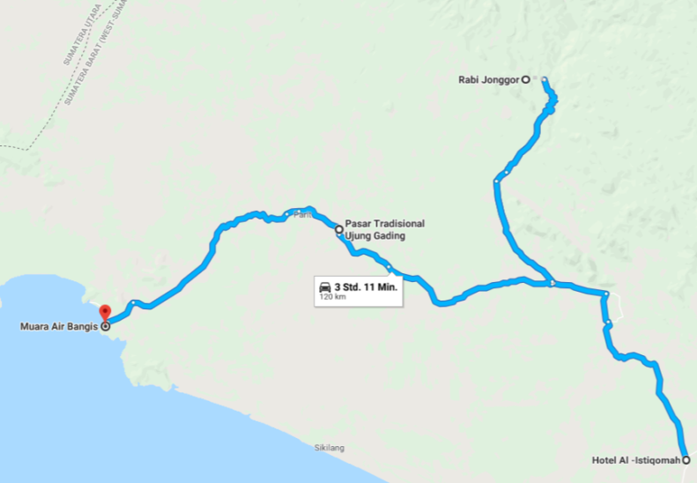
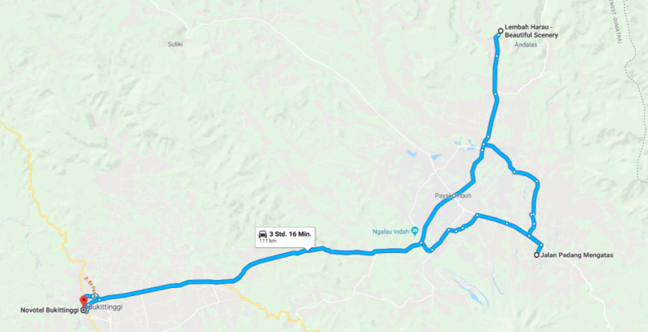
Here we present the options once again. "Rebooking" is possible until the end of January, after which the composition of the vehicle fleet is decided. If you don't want to make any changes, you don't do anything wrong, because every choice has its charms. But it helps us if we know that no other choice has been made.
On Saturday morning, 16.2., a city tour is planned. If you want to see something special, a certain street or building, please let us know. We try to accommodate this.
On Saturday afternoon there is either a tour to Bungus and beyond to Sungai Pisang (most have signed up for this) and a hike to Air Manis and Teluk Bayur.
Of course, you can also nostalgize alone at the market of Padang. In Pasar Raya Blok A there are corners where time has stood still. But Padang now also has big modern shopping malls: Plaza Andalas (Jl Pemuda, opposite the BPD, now Bank Nagari) and SPR Plaza (Jl Moh. Yamin, at the fountain at the entrance to Pasar Raya.) Google indicates the distance from the hotel with 350 m, 4 minutes on foot.
On Sunday, 17.2., the route to West Pasaman will be covered. We received an invitation from the Bupati of Pariaman for lunch at the beach. Most of us want to go there by train. Some want to take the opportunity to see Lake Maninjau again on this trip. (Others plan to do this on Wednesday, 20.2., on the way from Pasaman to Bukittinggi.)
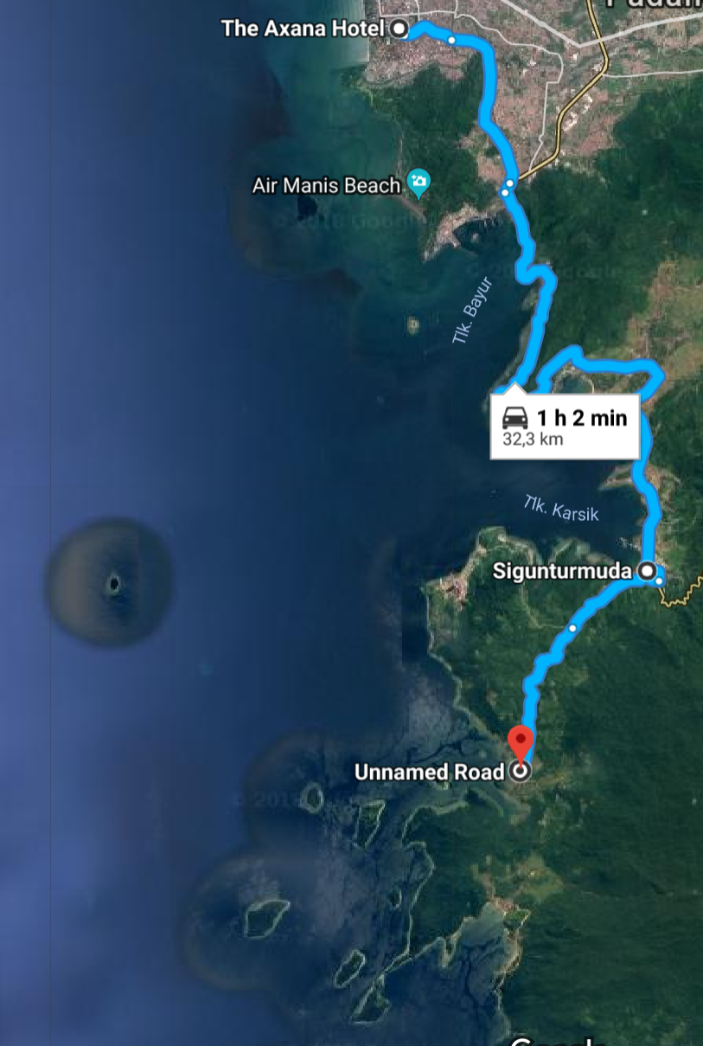
Sungai Pisang
Below: Kelok 44 to Lake Maninjau
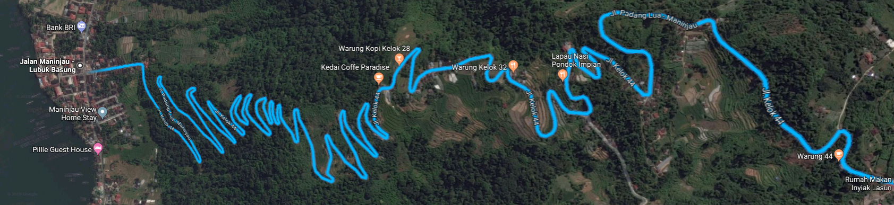
There is the possibility that we arrive so early in Simpang Empat (S IV) (about 16-17 o'clock) that we can still add 30 minutes to go to Sasak beach, enjoy coconut and sunset. Heinz-Josef Heile wrote: "In Sasak is now a Waterboom fun bath and the way there is certainly interesting". When we arrive there on Sunday, there will be one more sensation. By the way, the airport is on the road to Sasak.
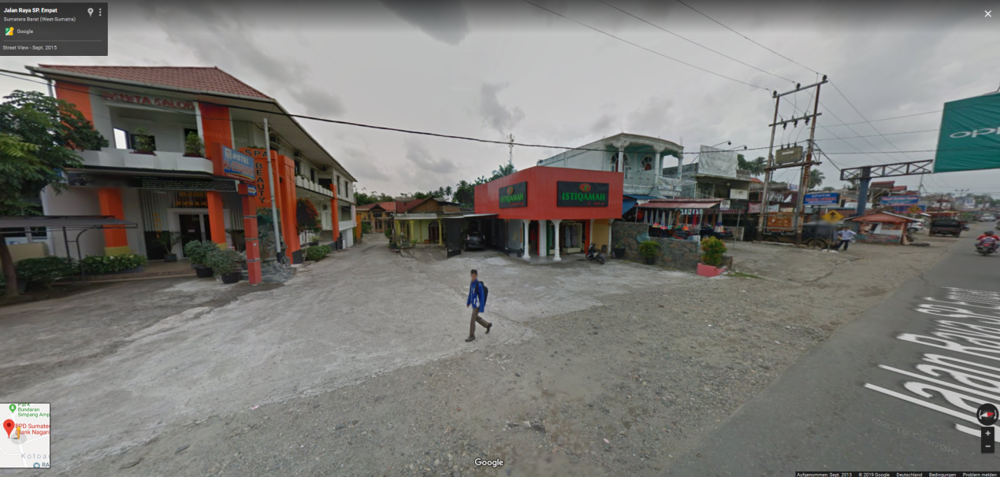
You can visit the Al-Istiqamah hotel in google street view. There are many pictures in the internet.

On Monday, February 18, we visit one of Indonesia's first rural bank branches, BPD Simpang Empat, and learn about the development. Afterwards (if necessary also before it) we pay a courtesy call to the regent (Bupati), whose office is almost just around the corner. We drive from there on the 4-lane highway to Sukamenanti and look how the various project buildings there are used now. For lunch we meet about 30 alumni who live in and around Sukamenanti. The afternoon still has room for creativity. A larger group is interested in the fate of the oil palm plantation Ophir. Others are more interested in infrastructure facilities: Education (schools, academies, health, banks, perhaps the fitness center still exists. I am also happy to receive suggestions here. We better announce our arrival at these locations.
The Regent (Bupati) invites us for a reception at his residence in the evening.
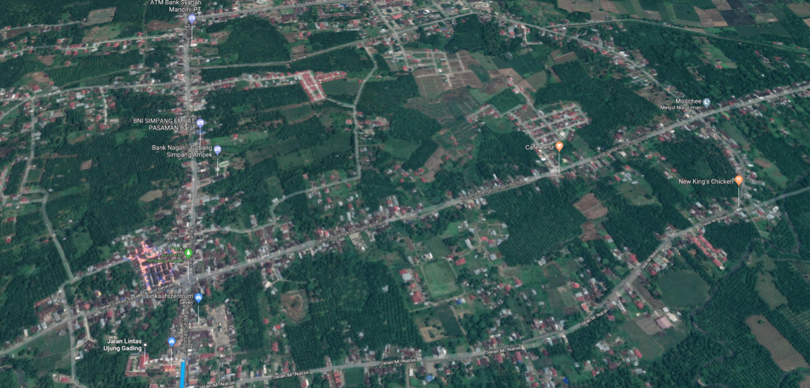
Simpang Empat: the intersection (roundabout) is on the lower left, up the road leads to Ujung Gading. Dark green: mostly oil palms in the "vegetable gardens".
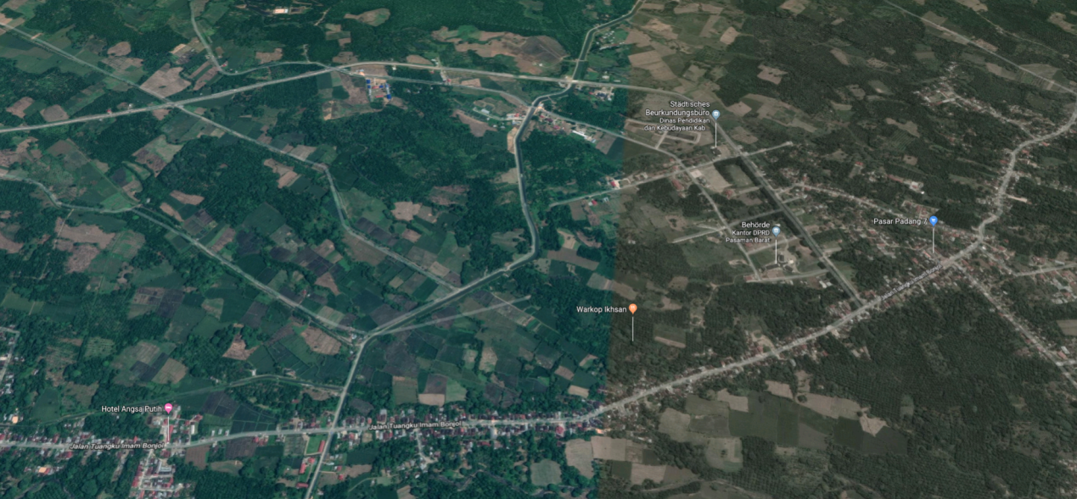
Sukamenanti: above from left to right with a slight curve the highway, in the middle of the right half of the picture are the ADP houses, far right is Padang 7. Street below: left to Simpang IV, right to Talu
NEW: On Tuesday, 19.2., we were offered to take a look at the outcome of the women's promotion activities in Rabi Jonggor. Tina has worked out a detailed plan for this day, including lunch in Ujung Gading. Depending on the remaining time frame, you may be able to either go to the old port of Air Bangis or head towards the border to Air Runding and North Sumatra. Most likely, there will be not enough time for both together. This offer has not yet been presented before, now we ask for registrations (if necessary changes).
The other two tours remain the same.
- Most registrations so far were for the trip to Air Bangis, from there to Air Runding and then to the border to North Sumatra.
- To Teluk Tapang, the new port about seven sea miles West of Air Bangis, one can drive allegedly only with off-road vehicles. The Regent/Bupati is very interested in showing us this infrastructure measure. Therefore, he provides us with a boat for the seafaring (going and coming back about 1:30 h). This trip could also be a small substitute for the two alumni who would have liked to have made a boat trip in Kinali. We dropped this alternative because of too little interest.
Since we want to meet in the evening with the alumni who live in Simpang III/IV or nearby, mainly Ophir-beneficiaries, we should be back by sunset (18:45) at the latest. This means to return from the farthest place about 16:00.
For the trip to Bukittinggi on February 20 and Padang on February 21 (we received an invitation from the Governor for this Thursday evening at 19:30) there are now the following options, which should be reconsidered with regard to the stay in Bukittinggi and the subsequent trip to Padang:
- You leave West Pasaman early in the morning (7:30?) on the old route via Panti with stops (e.g. in Talu, micro hydro power in Silayang) and a visit to the regent in Lubuk Sikaping (Bupati courtesy visit). One reaches Bukittinggi in the early evening, about 19 o'clock. By far the most participants are interested in this tour. In the evening you can still walk along the Jl A. Yani tourist mile in Bukittinggi and find small cosy restaurants. Attention, it can get cold down to 16°C! If you want to see something of Bukittinggi in the following morning, then the consequence is to take the Direttissima to Padang via Padang Panjang along the railway line. Currently it takes up to 3:00 hrs to get to the hotel in Padang. Because of a destroyed bridge you have to take a detour. The drive along the Singkarak Lake and Solok takes 4:30 hrs with stops for a cup of coffee or taking a picture. If you leave Bukittinggi at 13:00 at the latest, this is an alternative.
- You drive from West Pasaman in the morning directly or via Lake Maninjau to Bukittinggi, you will arrive in Bukittinggi at noon and have the whole Wednesday afternoon for Bukittinggi. If you drive via Lubuk Sikaping, it takes about 1.5 hours longer, time that is cut from the Bukittinggi time budget in the afternoon. You may leave West Pasaman very early in the morning – before breakfast. But is it this what you really want?
- If you want to see more in West Pasaman, you have to leave for Bukittinggi at noon. One arrives about 4 hours later (coffee break, photo stops) perhaps shortly before sunset. The consequences: If you want to see something from Bukittinggi, you have to do it the following morning and then drive on a shorter route to Padang, via Padang Panjang along the classic route along the railway track and railway bridges through the Anai valley, possibly with a stop at the waterfall (entrance fee!). But the track is also beautiful without a train! (From Ombilin no more coal reaches Padang.)
- Even if you already spent the afternoon 20.2. in Bukittinggi, you can experience town again the following morning, 21.2., and then drive directly to Padang in the afternoon. One should leave Bukittinggi in time, at the latest 15:00. The traffic jam has also arrived in West Sumatra. This route is always a bottleneck despite repeated extensions.
- You start in Bukittinggi in the morning on 21.2. to Padang, if you take a long round trip via Batusangkar (Minang Palace Pagaruyung, Cagar Budaya Ustano Rajo Alam, Istano Silinduang Bulan, Batu Batikam, Megaliths, maybe to the rice mill, delivered by GAWI almost 50 years ago), Lake Singkarak, Solok. Those who have seen enough, may take the shortcut to Padang,
- The restless ones drive to Danau Bawah, Danau Atas, Alahan Panjang, along the tea plantations of PTP Nusantara VI Danau Kembar, Panorama Padang, Indarung (cement factory).
- If you want to ride here (5, 6), and these are by far the most alumni, you have to answer the question: Have I seen already enough from Bukittinggi the afternoon before? Or is the evening walk through the alleys of the old town enough? Maybe in the early morning before breakfast you can quickly get to the panorama over Ngarai Sianok (Canyon) or to Benteng Fort de Kock (both about 10 minutes walk from the hotel). Or to the morning Pasar (some minutes more). Those who want to do this trip should reconsider the approach to Bukittinggi from the day before.
- NEW: Instead of spending the morning in Bukittinggi, there is still the option to drive to Padang Mengatas (ADP cattle breeding station) and to the scenic Harau valley with waterfall, a tour that takes about 4-5 hours with stops (about 9:00 - 14:00). In the afternoon we have to drive directly to Padang (about 15:00 - 18:00), so that we can arrive at the Governor's Residence in time and enjoy the evening.
If you have to drive directly from Bukittinggi to Padang, but would like to do the attractive round trip to Alahan Panjang and Danau Atas/Bawah and Solok, we will organize it for you on Friday, 22.2. or Saturday, 23.2. There are already interested parties. For an excursion to Batusangkar, one would have to plan 7:00 hrs alone for the driving time. That would only be something for the insatiable.
Because of the planning of the renting of the vehicles, here again the requests:
1. reconsider your tour selection: see the attached latest schedule
2. inform us "promptly", latest by Sunday, January 27, if you request a change
3. or to accept that we interpret missing information as "we are all right". But it would be helpful to learn that as well.

Communicate arrival
Most participants have submitted their arrival dates and time/ flight number at the airport in Padang. If we have all the dates, we can arrange the pick-up for some of you. Or we can tell you who arrives on the same plane or at the same time.
Please let us know the date, scheduled arrival time and flight number as soon as you have booked.

Hotel room: single/double
The hotels charge the same price for rooms regardless of whether one or two people sleep in the room and have breakfast. If you would like to share a room, please inform me. Double rooms have so far been reserved for eight couples. See Annex: Participants

Clothing
Of course, adapted to tropical temperatures. Think of a possibly cold night in Bukittinggi. Malaria or dengue fever cannot be excluded, but is not rampant. Short sleeves can be dared during the day (sun protection?). Despite Baygon and the spirals: There are still mosquitoes in the evening.
Who still has a batik shirt and if it still fits: that is always right with invitations in the evening. Honestly, specialists recognize the vintage of batik shirts by their design. (I'm robust here.) For the invitations, what Uli Scholz already successfully practiced as a hitchhiker 50 years ago applies: Always have a clean white shirt with you. Then, if necessary, a light jacket to go with it. The AC could be set too cold. But it is an informal evening with only one thing: no shorts (not even for the ladies) and no sandals please. (I don't think that necessarily applies to the ladies.)
(Bathing) clothing also includes sunscreen. This should be indispensable for those who go on a boat trip or are at the hotel swimming pool during noon. The air pollution in Padang (cement factory Semen Padang!) is usually not sufficient as a filter.

Diving and snorkeling
Andreas Kunzmann wrote: "There is a diving school in PDG, but he wants you to go out with him and pay (properly). So it's really easier if everyone brings their own stuff. I can try to bring 1-2 spare glasses, but certainly no second pair of fins. There is also the problem with the different shoe sizes.
A complete (light) set is available for 25 Euro. Have a look here e.g.
https://www.real.de/product/322373961/?kwd=&source=pla&sid=23490651&gclid=Cj0KCQiApbzhBRDKARIsAIvZue_Oe7hEZOJK566TJPjajq2tHXoOStQiK_m17vQb76MtMFzXAjQMohIaAqXcEALw_wcB

Hash House Harriers HHH
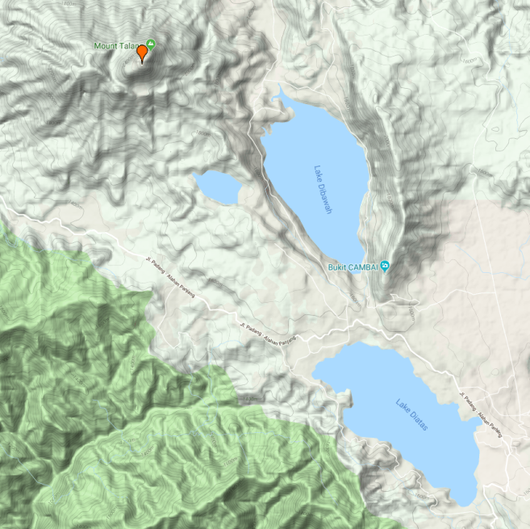
We invite the Hashers and others to join climbing the volcano Gunung Talang (2597 m, last eruption 2007). This volcano is not a big challenge, according to internet reports. We will not take risks and engage a guide. The views from the top are amazing – down to the three lakes of Danau Dibawah, Danau Diatas and the smaller Danau Talang (a crater lake) and in the early morning you should see Gunung Kerinci – Indonesia’s tallest volcano and Sumatra’s highest mountain, which some of you have already “done”.
Departure from Padang on Friday, 22.2., afternoon (1:30, 50 km to Pos Pendakian, near tea plantation).
Staying overnight at a guest house (at Bukit Sileh?)
Saturday: Climbing 2:30 to 6:30, about 1.100 m to top
Returning 8:30 – 11:30, Driving back to Padang, arrival about 13:30
Driving to Jambak Beach, arrival about 15:00: boat trip to island Sauh (2.5 km): relaxing, snorkeling. What a day!
Rain
We drive through one of the rainiest areas. For Kota Padang the annual rainfall is over 4,000 mm (Frankfurt 648 mm), in February it is at least below average (243 mm). Nevertheless, we recommend to take a small pocket umbrella or a large plastic bag with you.
Luggage
We travel with small buses, which cannot take the overseas luggage of all participants. Therefore we ask you to take a small bag with you, in which you can put what you need and your clothes for the four days 18, 19, 20 and 21. We have agreed with the hotel in Pasaman that the price includes the laundry of 2 clothes per person per day. (However, there are only two days available to hand in the laundry: Monday and Tuesday morning.) So you can be on the road with only a few things. As we return to the Axana Hotel, the (big) suitcase can wait there for our return on Thursday, 21.2.
Toilet
As part of our due diligence, we cannot visit every restaurant to test its toilet quality. Sometimes you are happy about a wooden shack. We would like to remind you to equip yourself with the essentials. Water bottles are usually on board and the drinking water is clean enough to wash your hands. And here the recommendation: get some medically cleaned charcoal (activated carbon) for few €. Please read on the Internet. I have made the best experiences with pills from the drugstore. The pharmacies offer expensive combined drugs. If you have not exposed your body to a foreign environment for a long time, it could react uncomfortably.
Drinks
There will be plenty of water in plastic bottles. Alcoholic drinks are officially frowned upon. (Also a reason why we cancelled the hash.) And beer is now subject to a heavy tax. By comparison, a bottle beer costs as much as champagne (not sparkling wine!), more than an average hourly wage. In the hotel at the bar probably 4 €. The Orang Barat will be tolerated for beer consumption. I will check how much beer there is left in West Pasaman. Anyway, we should wait with the beer in the evenings we spend at invitations until we are standing among ourselves at the hotel bar. Who hasn't learned to endure ice cubes in the Bir Bintang?

Did you know?
The collaboration with West Sumatra started around 1968. In February 1969 Uli Scholz explored the western part of the Kabupaten Pasaman for the first time, which was split off from Pasaman in 2003 as Pasaman Barat.
That was exactly 50 years ago! What a moment in time!

WhatsApp
For better information and communication among the participants, it helps to form a WhatsApp (WA) group. This is to reduce an "oh, I didn't know that" or "had I only known that". Not everyone needs to be connected. But those who are connected should please inform the others when relevant information is shared, for example, point of view or expected arrival, etc., so that they can be informed. Thomas will support us in this respect.

From: Thomas Krimmel [mailto:tkrimmel@gmail.com]
Sent: Thursday, 17. January 2019 17:58
To: Dieter Speidel
Subject: Re: Trip to West Sumatra - ALUMNI Whats app Group
Hello Dieter
A WhatsApp group is a good idea. I would need the telephone numbers of the participants as they registered on WhatsApp, i.e. not necessarily the current number. For example, Martina and I can always be reached on WhatsApp at our telephone number in Mauritius on WhatsApp, no matter where we are. For example, I talk to Martina in Zambia about it, with video, where we ourselves include our children in Berlin and The Hague, about the vidéo conference.
So send me the phone numbers of the group, then I set it up.
Best regards
Thomas

Thank you, Thomas. For Thomas and everyone else: my WA number is +49 157 753 357 32. And this is also my actual mobile phone number.

Governor's Invitation
Only those will be eligible to the Governor's Farewell evening, who disclose their relationship to West Sumatra. Most of you have submitted the data as requested in the previous Newsletter. For all others, here again the info we intend to provide:
1. Name of Project or relationship to a project in West Sumatra
2. Location of the project
3. Counterpart institution
4. Years you were in West Sumatra or worked for a project in West Sumatra (19... - 19...; not the number of years)
Sorry, please do not expect me to write individual Emails to those who have not submitted their data. Whatever you write - it is alright as long as it is not wrong.

Finances
In a previous newsletter we announced transport costs of € 120. We don't want to travel cramped. And even small groups of three or four participants should in principle be able to travel wherever they want to go. But it also makes sense to rent a larger vehicle instead of two smaller ones if many participants register for specific excursions. For this we need the information for the tours you want to participate in. We also don't yet know exactly what the total cost will be for our invitations. We also don't want our Indonesian partners, who don't just spend their time on this, to sit on the costs incurred for the preparation of the events. After a more exact estimation we will come back with this topic again. We ask you to accept the suggestion that the costs for transport, invitations and other additional costs will be transferred to Wolfram Hiemann's account in Euro in advance.
Cash
Cash holdings can be kept low.
- Most local transport costs and invitations are paid by bank transfer in Germany (see above). Costs are incurred for the airport transfer. See previous newsletter.
- Overnight stays and breakfasts in Padang and Bukittinggi can be paid by credit card.
- The hotel in Pasaman would like to be paid in cash. For this, roughly rounded up 100 € have to be charged.
- With 10 € a day you can get by, with more just better. An exchange of 100 € for food and other expenses is probably sufficient.
- There is also access to ATMs in West Pasaman. In Padang you can also change Euro.
It takes some getting used to the conversion at a rate of 1 Euro = Rp 16.100 to 16.600 in the past weeks. Very roughly:
+ Rp 10.000 are 60 €cent
+ Rp 50.000 are 3 €
+ Rp 100.000 are 6 € and
+ Rp 1.000.000 (one million) is about 60 €.

Documentation
Who dares to film a few scenes with their smartphone or camera? Please report! Pak Masri (GIZ Jakarta) takes a vacation to document our visit. But he can't be everywhere. He needs some support to record all activities. With some digital cameras and smartphones you can produce movies in HD quality or even Full HD. Pak Masri can then integrate the scenes into the final film. There are a few points to consider to enhance the movie (for Pak Masri the raw material). Pak Masri has compiled the most important tips for you (next newsletter). We hope that Pak Masri himself will also give some practical guidance. So, now there is a crash course "Better Filming" for free!
We would like to have a short documentation for each event/tour. Therefore we need a responsible documenter for each tour. Who is available as a documenter? Who dares to do that and passes on copies of his film recordings to Pak Masri? The result will be visible on the internet later. With names (but can be omitted if desired). Without honorarium. But there will be fair participation in potential marketing successes.

We are looking forward to the feedback and suggestions, questions. There will be at least two more newsletters. One is about finances and the other is a short report from West Sumatra.
Germany/Padang, 21 Januaryi 2019
For the Organizing Committee: Dieter Speidel, Emwady Noerdin, Wolfram Hiemann

In short:
- Review the schedule and activities you want to join. If necessary, report changes.
- Do you want to participate in boat trip to Sikuai island for (a) swimming, (b) snorkeling, (c) diving? Do you prefer (a) Saturday, 23.2., (b) Sunday, 24.2., or (c) no preference?
- Data on your project affiliation for the evening with the governor (if not yet submitted).
- Inform us about your arrival: date, time and flight number (if not yet submitted).
- We are open for suggestions and hints and tricks to be shared among the alumni.
- If you have old photos of specific interest: people, activities, history, please scan and submit.
- Report yourself as potential film contributor or documenter.
- Submit your WhatsApp (WA) number.

Arrival
Arrival date in Padang: ……………………..
Scheduled arrival time/Flight Code: …………………

Accomodation
All who have not yet submitted their accommodation requests, please fill in and return to w.hiemann@gmx.de Thank you!
Please inform us, we will do the booking – unless you want it otherwise

Accomodation in Padang
- I will stay at The Axana Hotel: Yes or No (I make other arrangements):
- Standard program, three nights Yes or No:
if you do not arrive earlier and/or depart later we will book
standard three nights: 15/16; 16/17; 21/22
I arrive earlier and/or depart later:
- will check in at The Axana Hotel earlier on: day, DD/MM.
- will check-out later, on: day, DD/MM.

Room preference at Al-Istiqamah Hotel in West Pasaman:
- Superior
- Deluxe
- VIP
In case there are not enough AC rooms available in this hotel:
- I am ready to stay in another AC hotel in West Pasaman Yes or Never
- Other advice:
Preferred accomodation in Bukittinggi
- Novotel or Grand Rocky
- Any less luxury hotel, but equally (centrally) located (such as Benteng)

General information about you and West Sumatra
- Name of Project or relationship to a project in West Sumatra
- Location of the project
- Counterpart institution
- Years you were in West Sumatra or worked for a project in West Sumatra (19... - 19...; not the number of years)

Friday, 15 Arrival and Meeting

Afternoon  Evening | 18:00 Meeting of the Participants (venue to be announced)  19:30 Joint dinner with former counterparts and project staff
Saturday, 16 in/around Padang
Morning | 9:30 City Tour
Afternoon | a) to Bungus and beyond: Teluk Bayur (palm oil tanks), Carolina Beach, Chinese cemetery, (Pertamina tanks and power station), Sungai Pisang beach with opportunity to swim and enjoy a coconut ~ 1:30, 40 km  18:00 from Sungai Pisang to Lighthouse or “Panorama Teluk Bayur” ~0:50, 30 km |  | b) walking to Teluk Bayur via Air Manis (entrance fee Rp 5,000), opportunity to swim, legendary Batu Malin Kundang,  walking from hotel 2:15, 10 km,  - ~ 0:30 less if walking starts at the river,  - ~0:30 more if climbing Padang hill  pick-up at Teluk Bayur ~18:00  to Lighthouse or “Panorama Teluk Bayur”  ~0:20, 10 km
Participants per 11.01. | 12 |  | 5
Sunset | 18:40 at Lighthouse or “Panorama Teluk Bayur”  Snack and drink, return to hotel at 19:10 (~0:30, 15 km)
Evening | Seafood Restaurant at Padang Beach Jalan Samudera?
Sunday, 17 From Padang to West Pasaman
Morning | a) Train to Pariaman, Rp 5.000  (09:00-10:36),  walk to Pariaman beach | b) to Pariaman via Lubuk Alung  old road: ~ 1:30, 60 km | c) New small road to Pariaman along the coast  same: ~ 1:30, 60 km | d) to Simpang Empat via Maninjau (Kelok 44), Lubuk Basung, Manggopoh  (not via Pariaman)  ~ 5:30, 220 km
Noon | 12:00 Bupati Pariaman invites for lunch at beach
Afternoon | Pariaman - Simpang IV (~2:20, 120 km)
Participants per 11.01. | 7 | 5 | 5 | 2
Late afternoon | Depending on arrival time: trip to Sasak beach: sunset, dinner? (from hotel ~ 0:30, 20 km)
Monday, 18 in West Pasaman around Simpang Empat
Morning | Simpang Empat, Bank Nagari (BPD), Bupati office, Sukamenanti, Pasar Padang Tujuh  ~ 0:15, 9 km
Noon | 11:30 Meeting and lunch with former counterparts and staff
Afternoon | - Ophir oil palm plantation  and farmer organization  Padang Tujuh – TC IV ~ 0:25, 12 km  TC IV – Hotel ~ 0:25, 15 km |  | b) other visits: Education, Health, Transportation (Airport Simpang Empat), Sasak fishery, Kapar fish hatchery, etc.
Participants per 11.01. | 13
Evening | Invitation from Bupati at his residence

Tuesday, 19 in West Pasaman
Morning | a) Ujung Gading, Air Bangis (Aia Bangih) (2:00, 90 km), Air Runding, North Sumatra border (1:00, 45 km), back to S IV (2:15, 95 km), Total ~ 5:15, 230 km | b) Ujung Gading (1:10, 50 km), old harbour Air Bangis (0:50, 40 km) , by boat to new harbour Teluk Tapang (0:45 - special recommended by Bpk Bupati), back  to S IV (2:45, 90 km),  Total ~ 5:30, 180 km  (plus 25 km by boat) | c) Rabi Jonggor (Women activities) (1:15, 50 km), Ujung Gading (1:15, 45 km)
Noon |  |  | Ujung Gading (Tina: invitation to lunch)
Afternoon |  |  | c1) to Air Bangis (0:40, 30 km), back to S IV (1:50, 75 km) Total ~ 5:00, 200 km | c2) to Air Runding, North Sumatra border (1:00, 45 km), back to S IV (2:15, 95 km), Total ~ 5:45, 240 km
Participants per 11.01. | 13 | 5 | This activity is new.
Evening (tentatively) | 19:30 Dinner with Ophir farmers and alumini in Simpang IV/III (TC I Ophir?)
Wednesday, 20 from West Pasaman to Bukittinggi
 | a) All day travel | b) Morning in West Pasaman -- afternoon travelling to Bukittinggi | c) Morning travelling to Bukittinggi, afternoon exploring Bukittinggi
Morning | a) Talu, Cubadak (blacksmiths), Panti (hot springs), Silayang (micro hydro power), Lubuk Sikaping (Bupati meeting), Bonjol (Museum/monumen Tuanku Imam Bonjol, equator monument);  travelling ~7-8 hrs | b) West Pasaman: Visit opportunities to some of the following: oil palm factory, Ophiir Bank, Ophir Computer School, Airport and Sasak Beach, Talu, Kapar fish hatchery, etc. | c1) via Talu. Panti (hot springs), Lubuk Sikaping, Bonjol (Museum/monumen Tuanku Imam Bonjol equator monument);  ~ 4:30, 180 km | c2) via Lake Maninjau, ~ 3:15, 133 km –  c3) fastest and shortest via Bonjol:  ~ 2:50, 110 km
Afternoon |  | Travel to Bukittinggi:  b1) via Talu, Panti, Lubuk Sikaping ,  b2) via Maninjau | Bukittinggi
Paticipants per 11.01. | 15 | 6 | 2 | 5
Thursday, 21 from Bukittinggi to Padang
Morning | a) Bukittinggi: Pasar, Fort de Kock, Panorama Ngarai, etc. | b) Travel to and visit of Padang Mengatas, Harau valley with waterfall, return to Bukittingi,  Total ~ 3:15, 120 km | c) Full day via Batusangkar (Pagaruyung Palace, megaliths), Lake Singkarak, Solok, Alahan Panjang, Danau di Bawah/Atas, Panorama Padang, Total ~ 5:45, 200 km | d) Other, e.g., travel to Lake Maninjau
Afternoon | directly to Padang (classic route) via Padang Panjang, Anau waterfall, Sicincin, Lubuk Alung ~ 2:30 - 3:00 (broken bridge!), 100 km  or via Singkarak, Solok ~ 3:30, 130 km
Participants per 11.01. | 4 | 4 | 14 | 4
Evening | 19:30 Gouvernor's invitation, Farewell Party, Padang
Other activities | Visit to Abai Siat  (Fr, 22.2. - Th, 23.2.) | Climbing Vulcano Talang (Solok)  Climbing about 1,000 m  Dep. afternoon 22.2., return early afternoon 23.2., swim, coconut and sunset at Jambak | Boat/island tour,  For snorkeling, bring your own equipment.  Offered for Sa, 23.2. or Su, 24.2.  (presently preferred) | Round trip Solok Danau di Bawah/Atas  Very scenic! To be considered, If you return from Bukittinggi the classic route: (see 21.2.:  Tour a) or b)
Participants per 11.01. | 5 | 2 | 7 | 3

After considering the low number of serious hashers (4), aspects concerning culture and environment as well as lack of shredder and unnecessary project papers, it is not very likely to organize a hash. The Gunung Talang is probably the easiest to climb in West Sumatra. I opt for this one.
WH, 20.01.2019

